README

This package contains 5 Script’s that can be useful for you during the development of your game.
All of them are being used in the Demo Scene, you can use her as reference of how to apply the scripts during the development.

The Scripts are:

1° HoverAnim

2° Menu & Menu Manager

3° Sound Manager

How to use them will be explained on the next page:

1° Hover Anim
This script will make the UI under the mouse bigger.

Example:
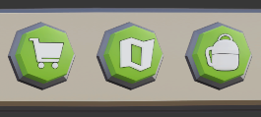 No Mouse
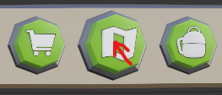 With Mouse

HOW TO USE IT:
Add the “HoverAnim” Component to the UI game object you want to have this effect.
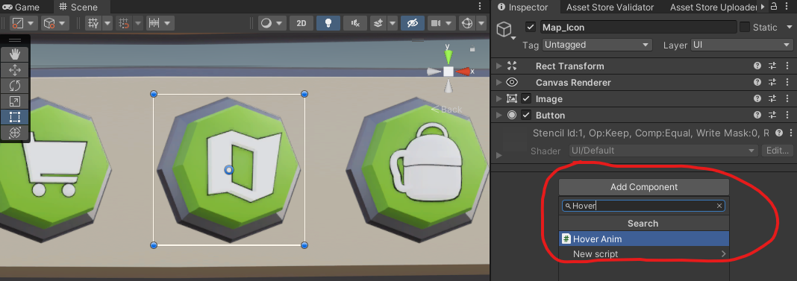

The component will have two parameters:
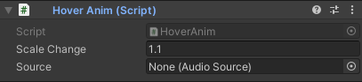
Scale Change (float): Used to determine the growth of the game object when under the mouse.
Source (Audio Source): Used to play a sound effect with the hover animation.

If you don’t want to play any sound, you can just leave the Source parameter empty. However, if you do want to play a sound, add a “Audio Source” Component to the game object. 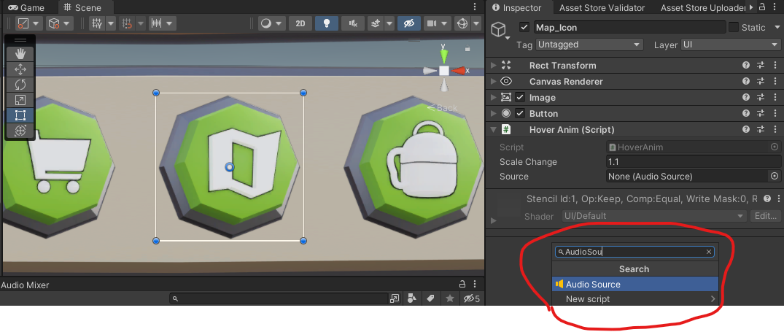
Then add a “Audio Clip” to it.
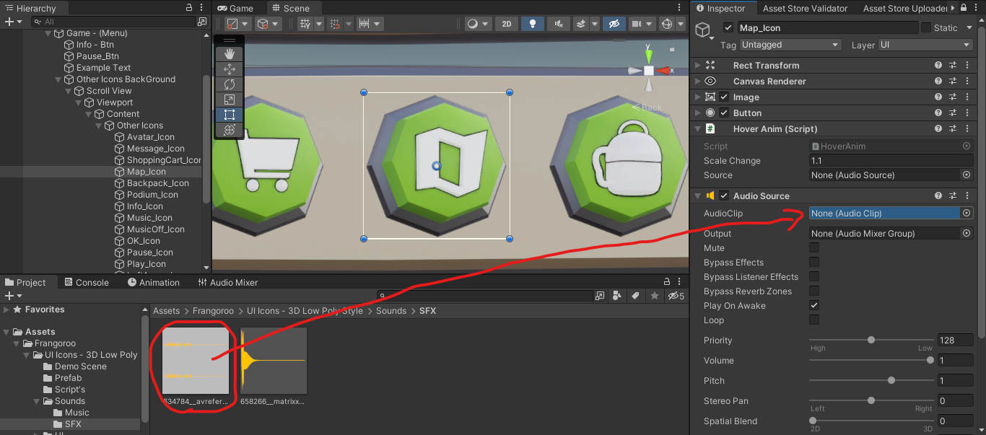

Uncheck the Play on Awake parameter, and drag the “Audio Source” to the Source parameter on “Hover Anim”

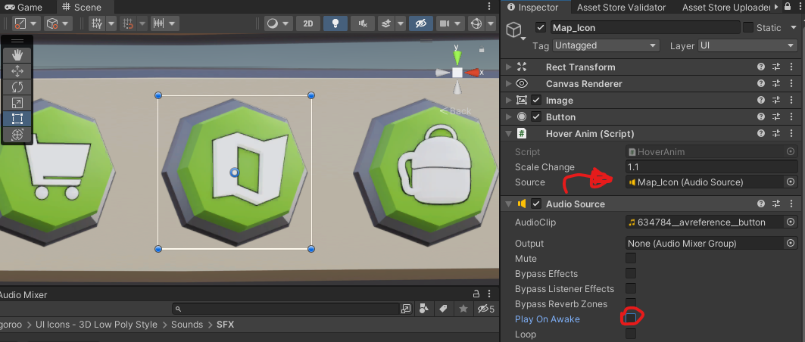

And done. The, “HoverAnim” is now working.

2° Menu & MenuManager

These scripts will control when, and how to change the menus used on the scene.

HOW TO USE IT:

First, Add the “MenuManager” Component to a game object that stays active during the scene. (In this case I’ll be attaching it to the Canvas)
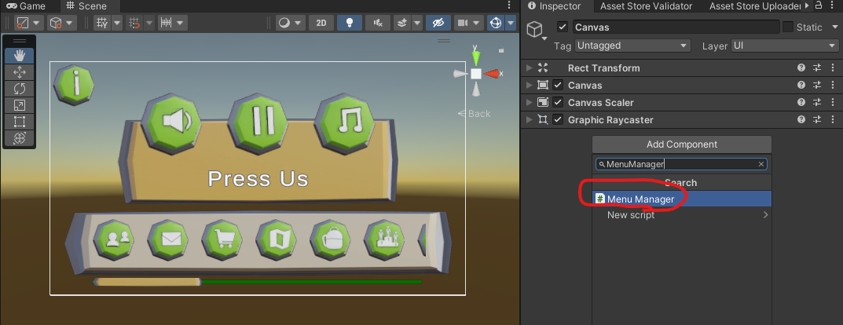

Now, add the “Menu” Component to the game object with your menu. In the following case I’ll be attaching it to “Game (Menu)”, this game object has my gameplay UI within it.
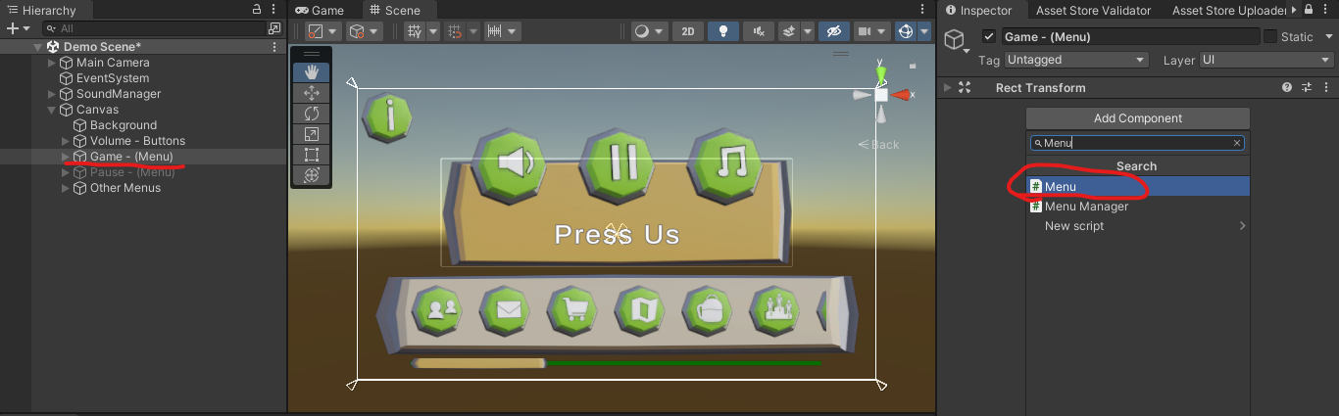
In the “Menu” component you will see two parameters.
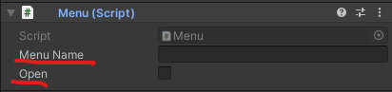

Menu Name (string): Used to identify the Menu
Open (boolean): Used to determine which Menu start’s the scene already opened.

At Menu name, type a unique name for this menu.
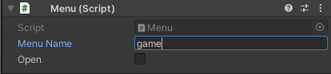
Open should only be marked if the menu starts the scene already opened.
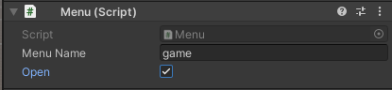

Now repeat the same process with as many Menu game objects you like. Here I’m going to do it again with the “Pause (Menu)”.
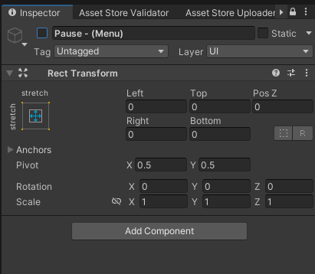 Before

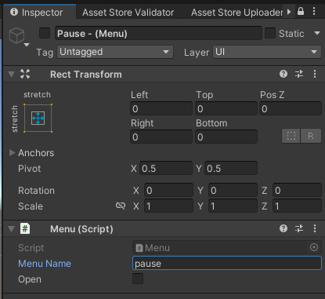 After

Now, open the “MenuManager” component we attached early on the Canvas.

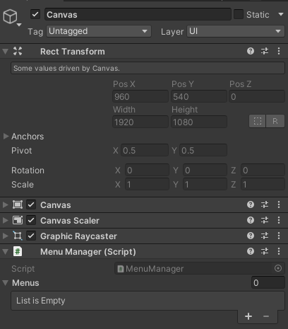

Drag all the game objects with “Menu” component that you have just created to the List inside “Menu Manager” called Menus.
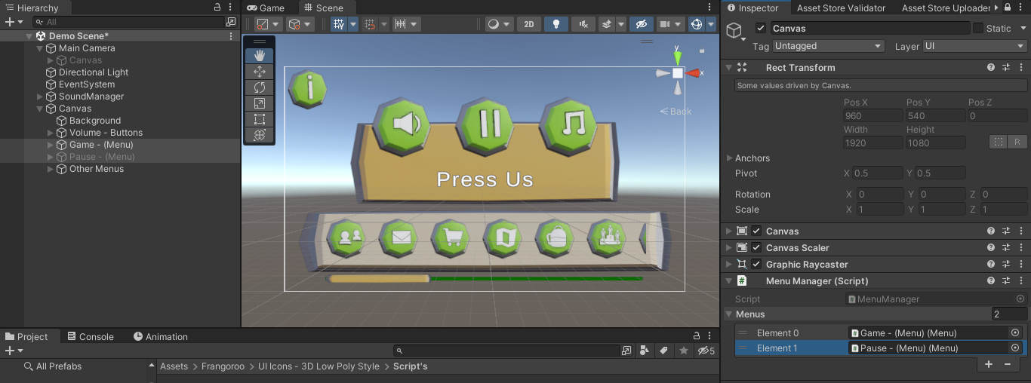

And done! Now you just have to call the function “Open Menu” (that resides inside “MenuManager” script) and pass the string with the name of the Menu you desire to open.

In the following example I will use a Button to call the “OpenMenu” function. But you can also call this function through a script.
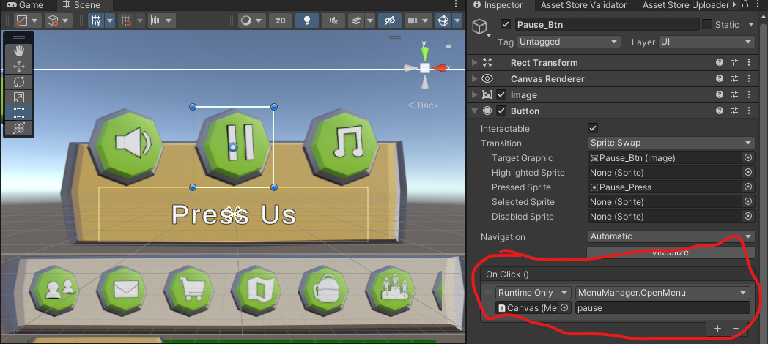

Now if you press the button, you can see that the MenuManager script will close the current Menu, and open the one you desired.
3° SoundManager

Create a new Empty game object, I’ll call it “SoundManager”
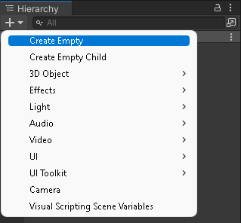

Add the “SoundManager” component to it
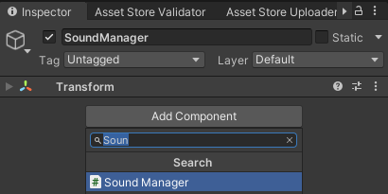
Within it you’ll have nine parameters
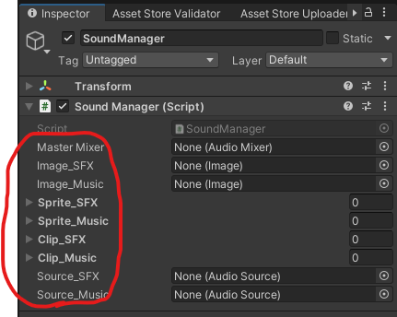
Master Mixer (Audio Mixer): Used to control the Mixer volume.
Image SFX (Image): Is the Image of the button that’ll Mute & Unmute the SFX.
Sprite SFX (Sprite): Are the Mute, and Unmute sprites related to the SFX.
Clip SFX (Audio Clip): Drag the Audio Clips you’ll be using as sound effects in here.
Source SFX (Audio Source): Audio Source responsible for the Sound Effects.
Image Music (Image): Is the Image of the button that’ll Mute & Unmute the Music.
Sprite Music (Sprite): Are the Mute, and Unmute sprites related to the Music.
Clip Music (Audio Clip): Drag the Audio Clips you’ll be using as music in here.
Source Music (Audio Source): Audio Source responsible for the Music.
To control the volume of your sound effects, and music.

1° Step - At Master Mixer drag and drop the “Audio Mixer” located within “Sounds” folder.
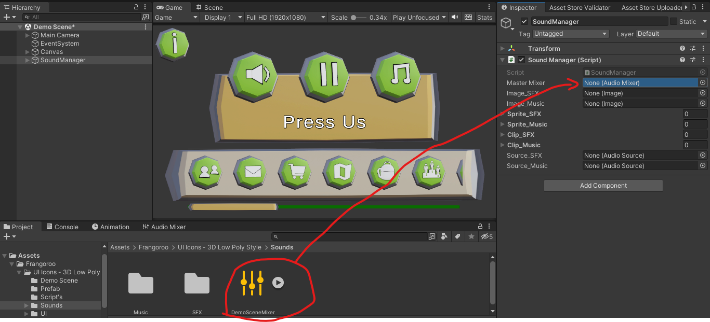
2° Step - Go to your SFX Slider game object, within it access the “Slider” Component, and change the parameter Min Value to -50, and add a new On Value Changed parameter.
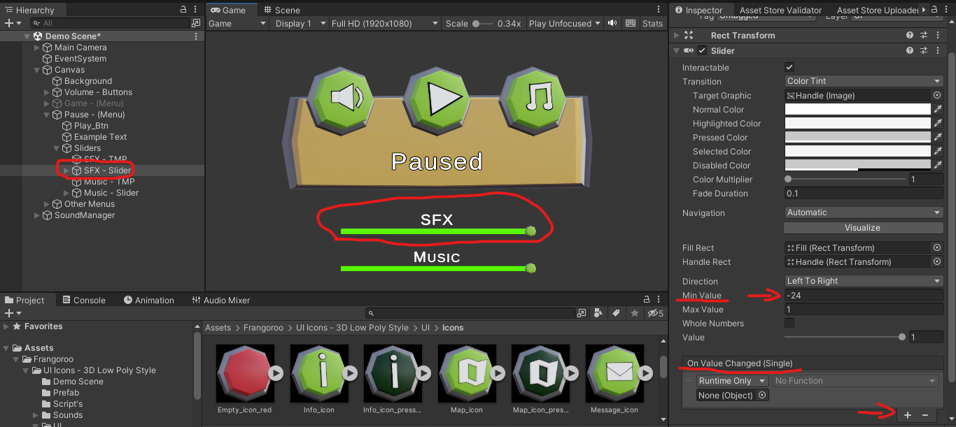
3° Step - Drag and drop the “SoundManager” game object to the On Value Changed parameter we just created. 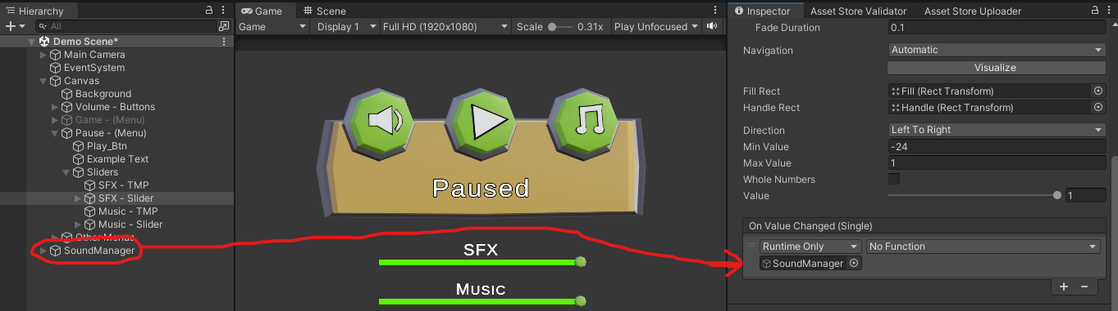
4°- Add the Dynamic float “ChangeVolumeSFX” in the parameter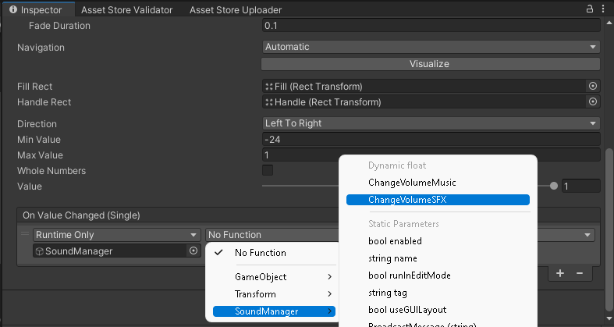
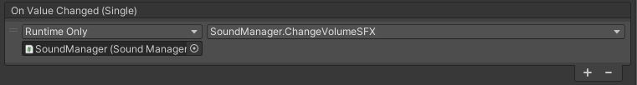
Now repeat the last 3 steps with the Slider responsible for the Music, but instead of using “ChangeVolumeSFX”, use the “ChangeVolumeMusic” dynamic float.
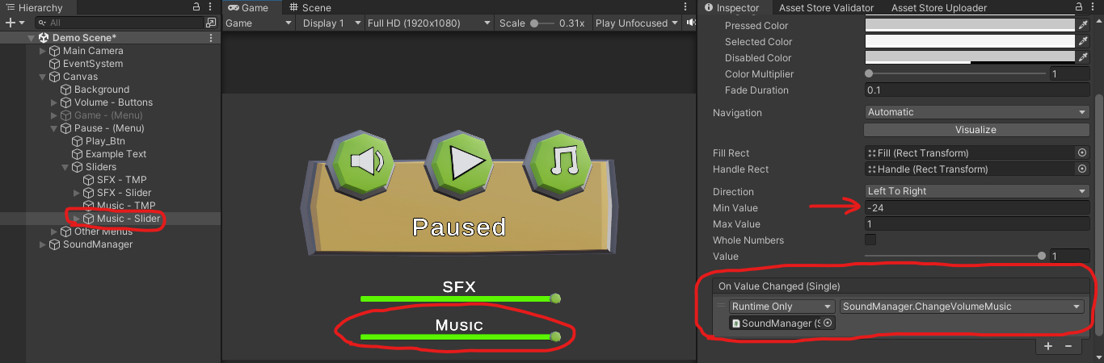
5° Step – Select all the game objects with a “AudioSource” Component that will play a sound effect, and change their Output parameter to “SFX”. 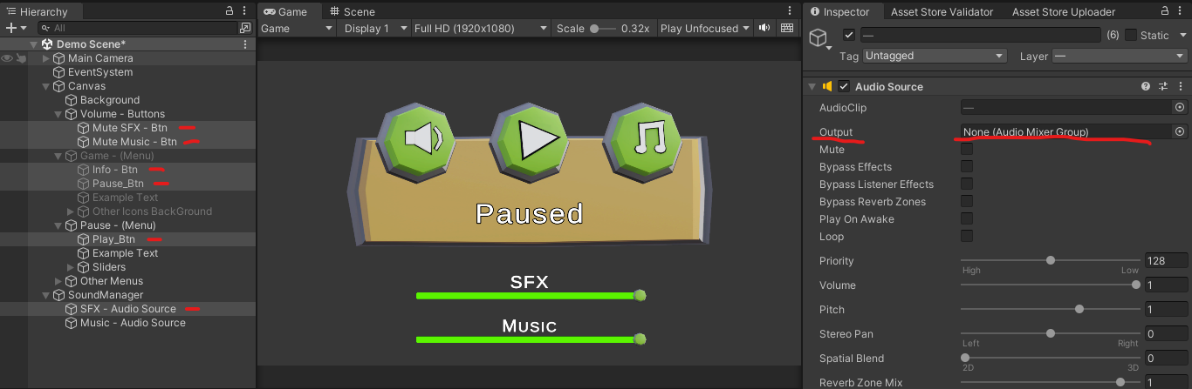
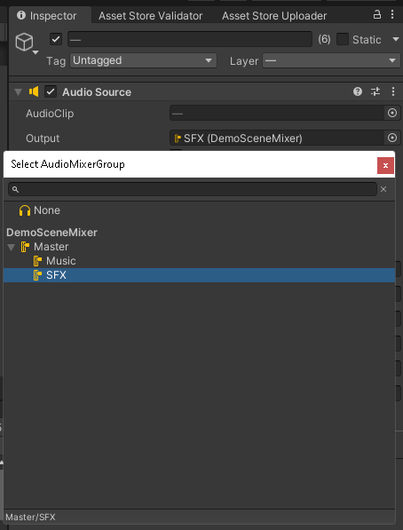
Now repeat the last step with the “AudioSource” for Music, but instead of changing the Output to the “SFX” Mixer Group, use the “Music” Mixer Group.
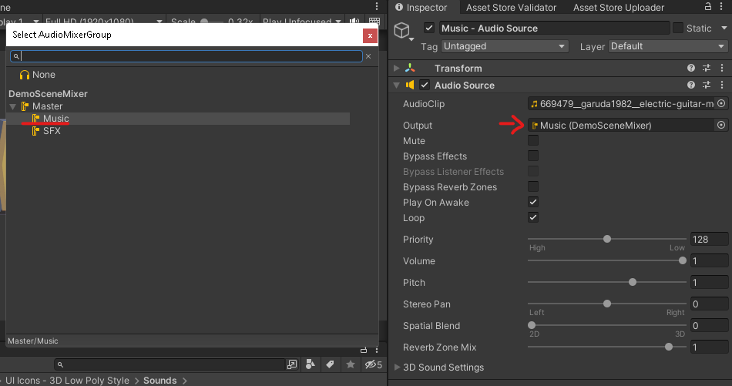

And done, you’re now able to change the volume for the Music, and Sound Effects of your game.

To mute, and unmute the volume of your sound effects, and music.

1° Step - At Image SFX, drag and drop the Button you’ll be using to mute & unmute the sound effects.
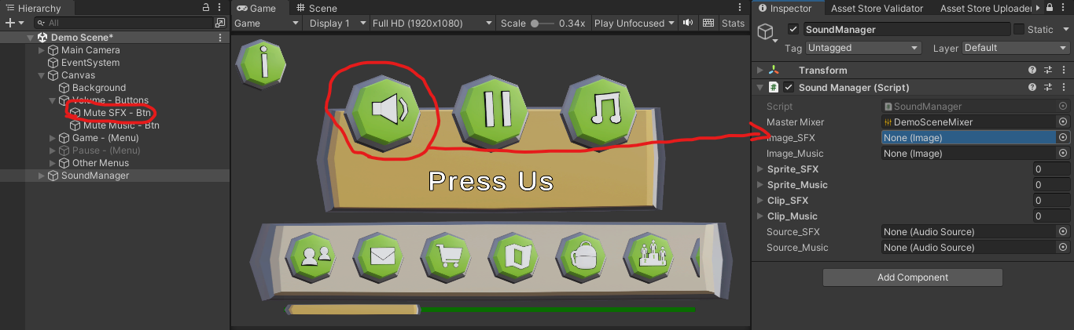

2° Step - At Image Music, drag and drop the Button you’ll be using to mute & unmute the music.
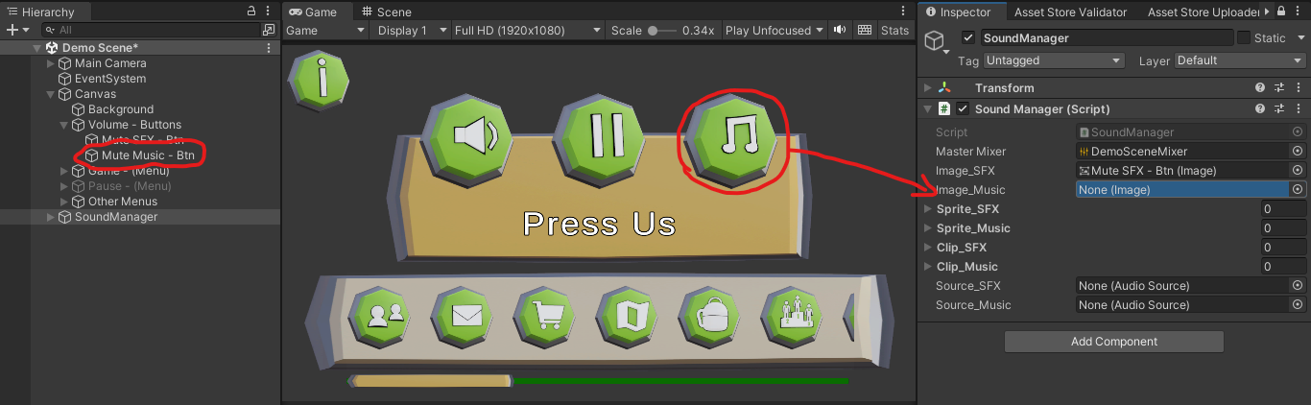
3° Step - At Sprites SFX, drag and drop the sprites you’ll be using for the mute state, and unmute state related to SFX. (In this order)
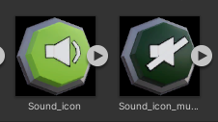
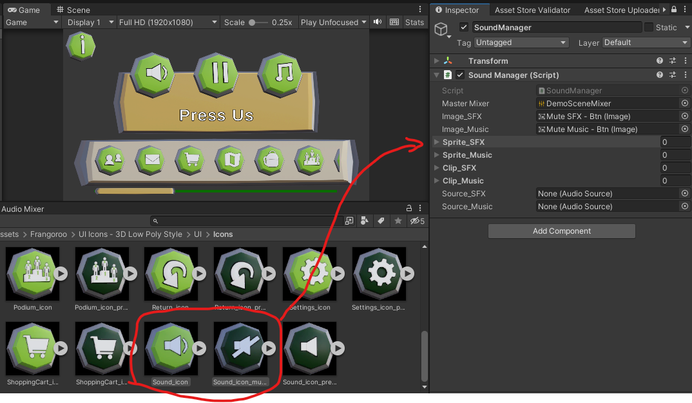

4° Step - At Sprites Music, drag and drop the sprites you’ll be using for the mute state, and unmute state related to Music. (In this order)
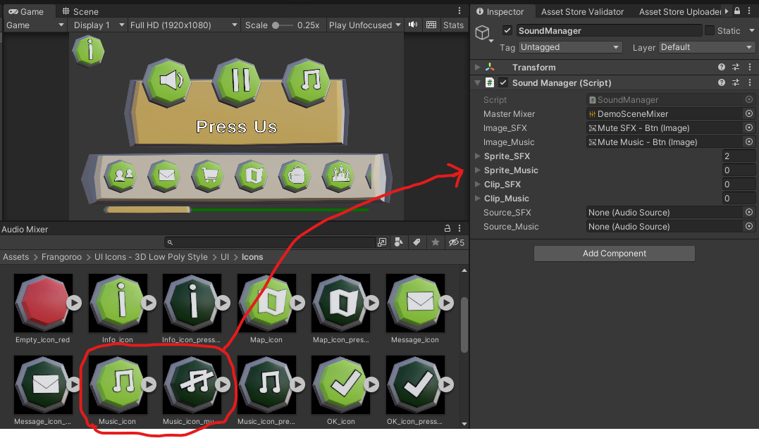
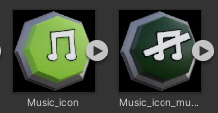

5° Step – Go to the button you’ll use to mute/unmute the sound effects, and add a new “OnClick” parameter 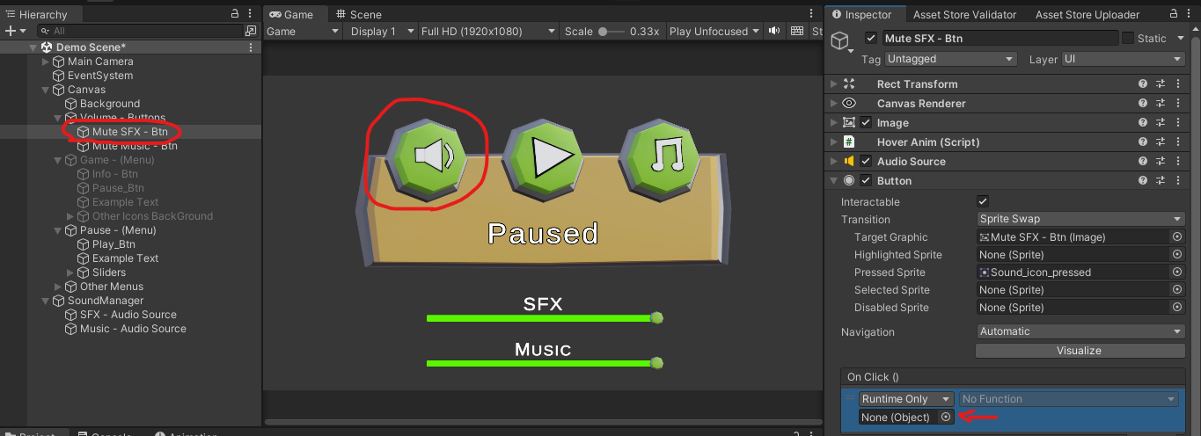
6° Step - Drag and drop the “SoundManager” game object to this parameter, and then select the function “MuteSFX” 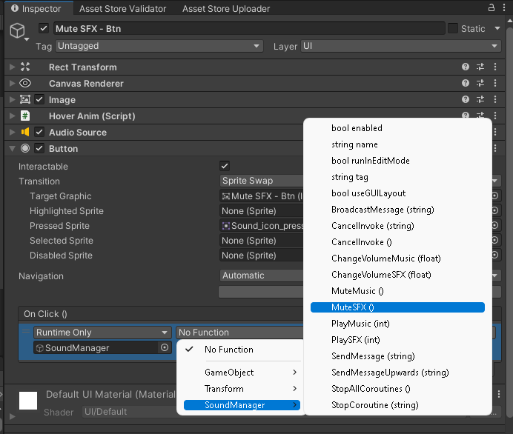
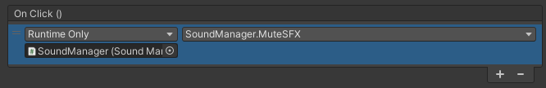
Now repeat the last 2 steps for the mute/unmute Button related to the Music, but instead of using the “MuteSFX”, use “MuteMusic” function.

And done. Now if you click the Buttons, you’ll see that they change the sprite, to indicate when is muted or not, and change the Volume of the desired Mixer Group.

To play an SFX, or Music through the Sound Manager.

1° Step – Drag the “Audio Clips” you want to play via script as sound effects to the Clip SFX List. 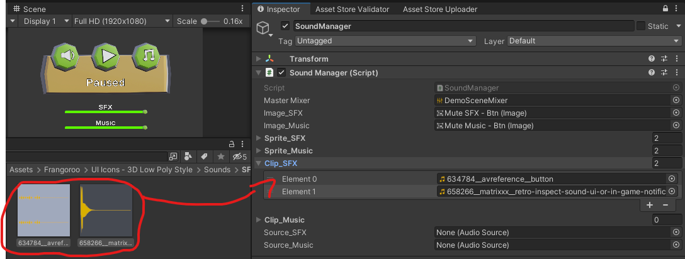

2° Step – Drag the “Audio Clips” you want to play via script as Music to the Clip Music List.
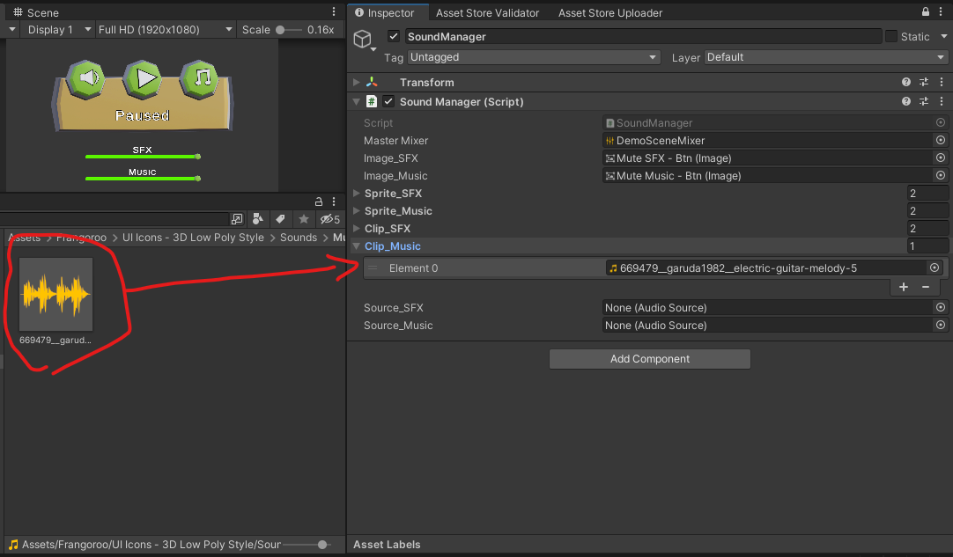

3° Step – Create two “Audio Sources”. One to play the sound effects, the other to play the Music. I’ll create them within the Sound Manager game object. 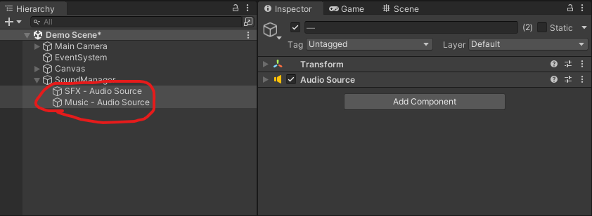

4° Step – Drag each “Audio Source” to their designed parameter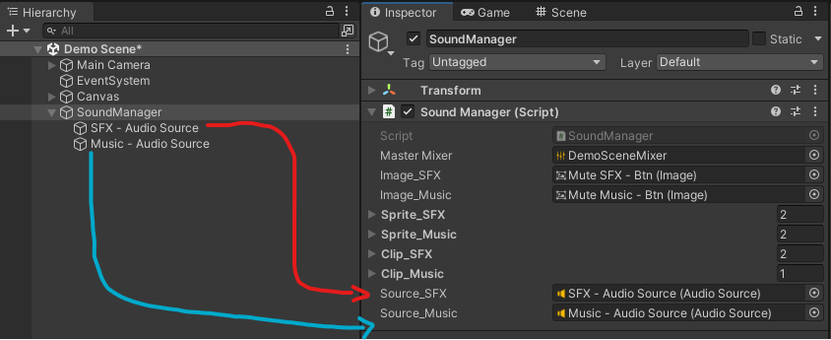
And now everything is set up and ready.

You can call the function “PlaySFX” located within “SoundManager” and pass the Element number of the SFX you want to play. Check the following example.
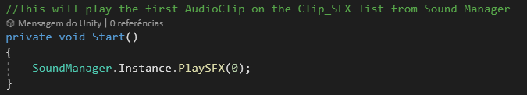

You can call the function “PlaySFX” located within “SoundManager” and pass the Element number of the SFX you want to play. Check the following example.
